Ans 13-

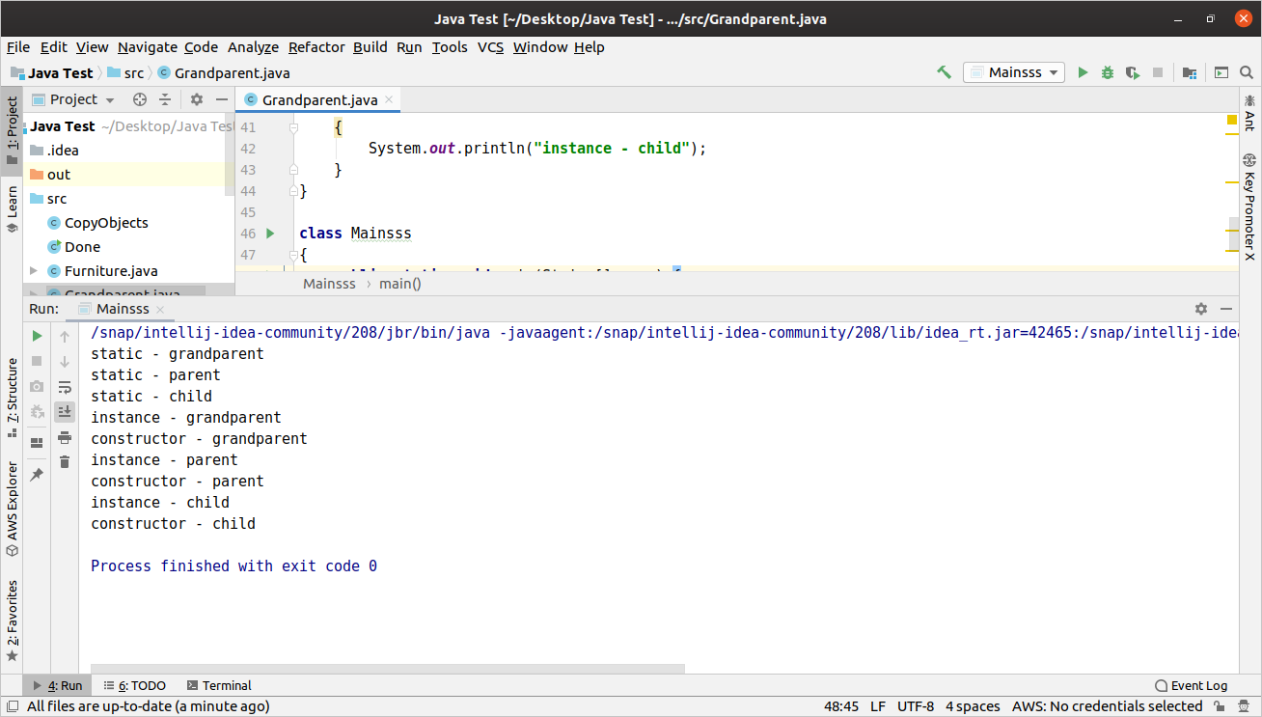
Static Methods run first then others

Parents class’ Constructor runs first then Child class’

